UNKT

SDGs and Targets Guide

Open Data Kosovo 2017

**Table of contents**

**How to open the plugin** **3**

**Manage Targets** **4**

Creating new target 4

Editing targets 5

Deleting targets 6

**Manage Indicators** **7**

Creating new indicator 7

Editing indicators 9

Deleting indicators 10

**Manage charts** **11**

Creating new chart 11

Chart with unit as Numbers 13

Chart with unit as Percentage and Number 14

Chart with unit as only Percentage 15

Chart with Comparative Value 16

Chart with unit as Ratio 17

Chart with unit as Yes/No 18

Chart with unit as Increasing 19

Chart with unit as decreasing 20

Complex chart with more than one data entry 21

Editing charts 23

Deleting charts 24

# **How to open the plugin**

Follow the instructions listed below

1. Login with your account in the dashboard of UNKT.org
   1. Go to <http://unkt.org/wp-admin>
   2. Login with your account
2. 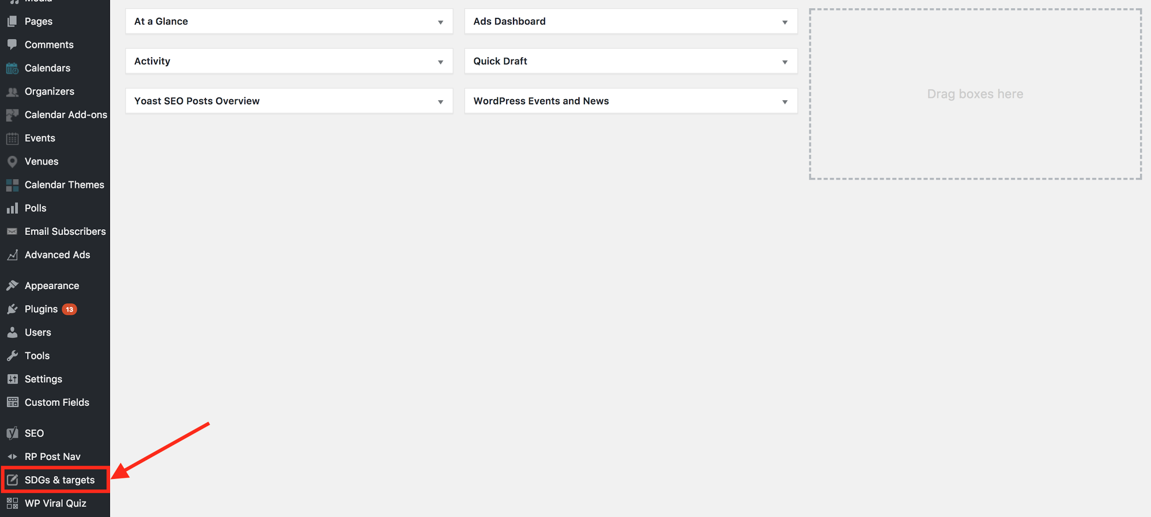Find the menu item called “SDGs & Targets” in the left hand side navigation.
3. Click on that “SDGs & Targets” item.

You will see the dashboard of “SDGs & Targets” opened as below:

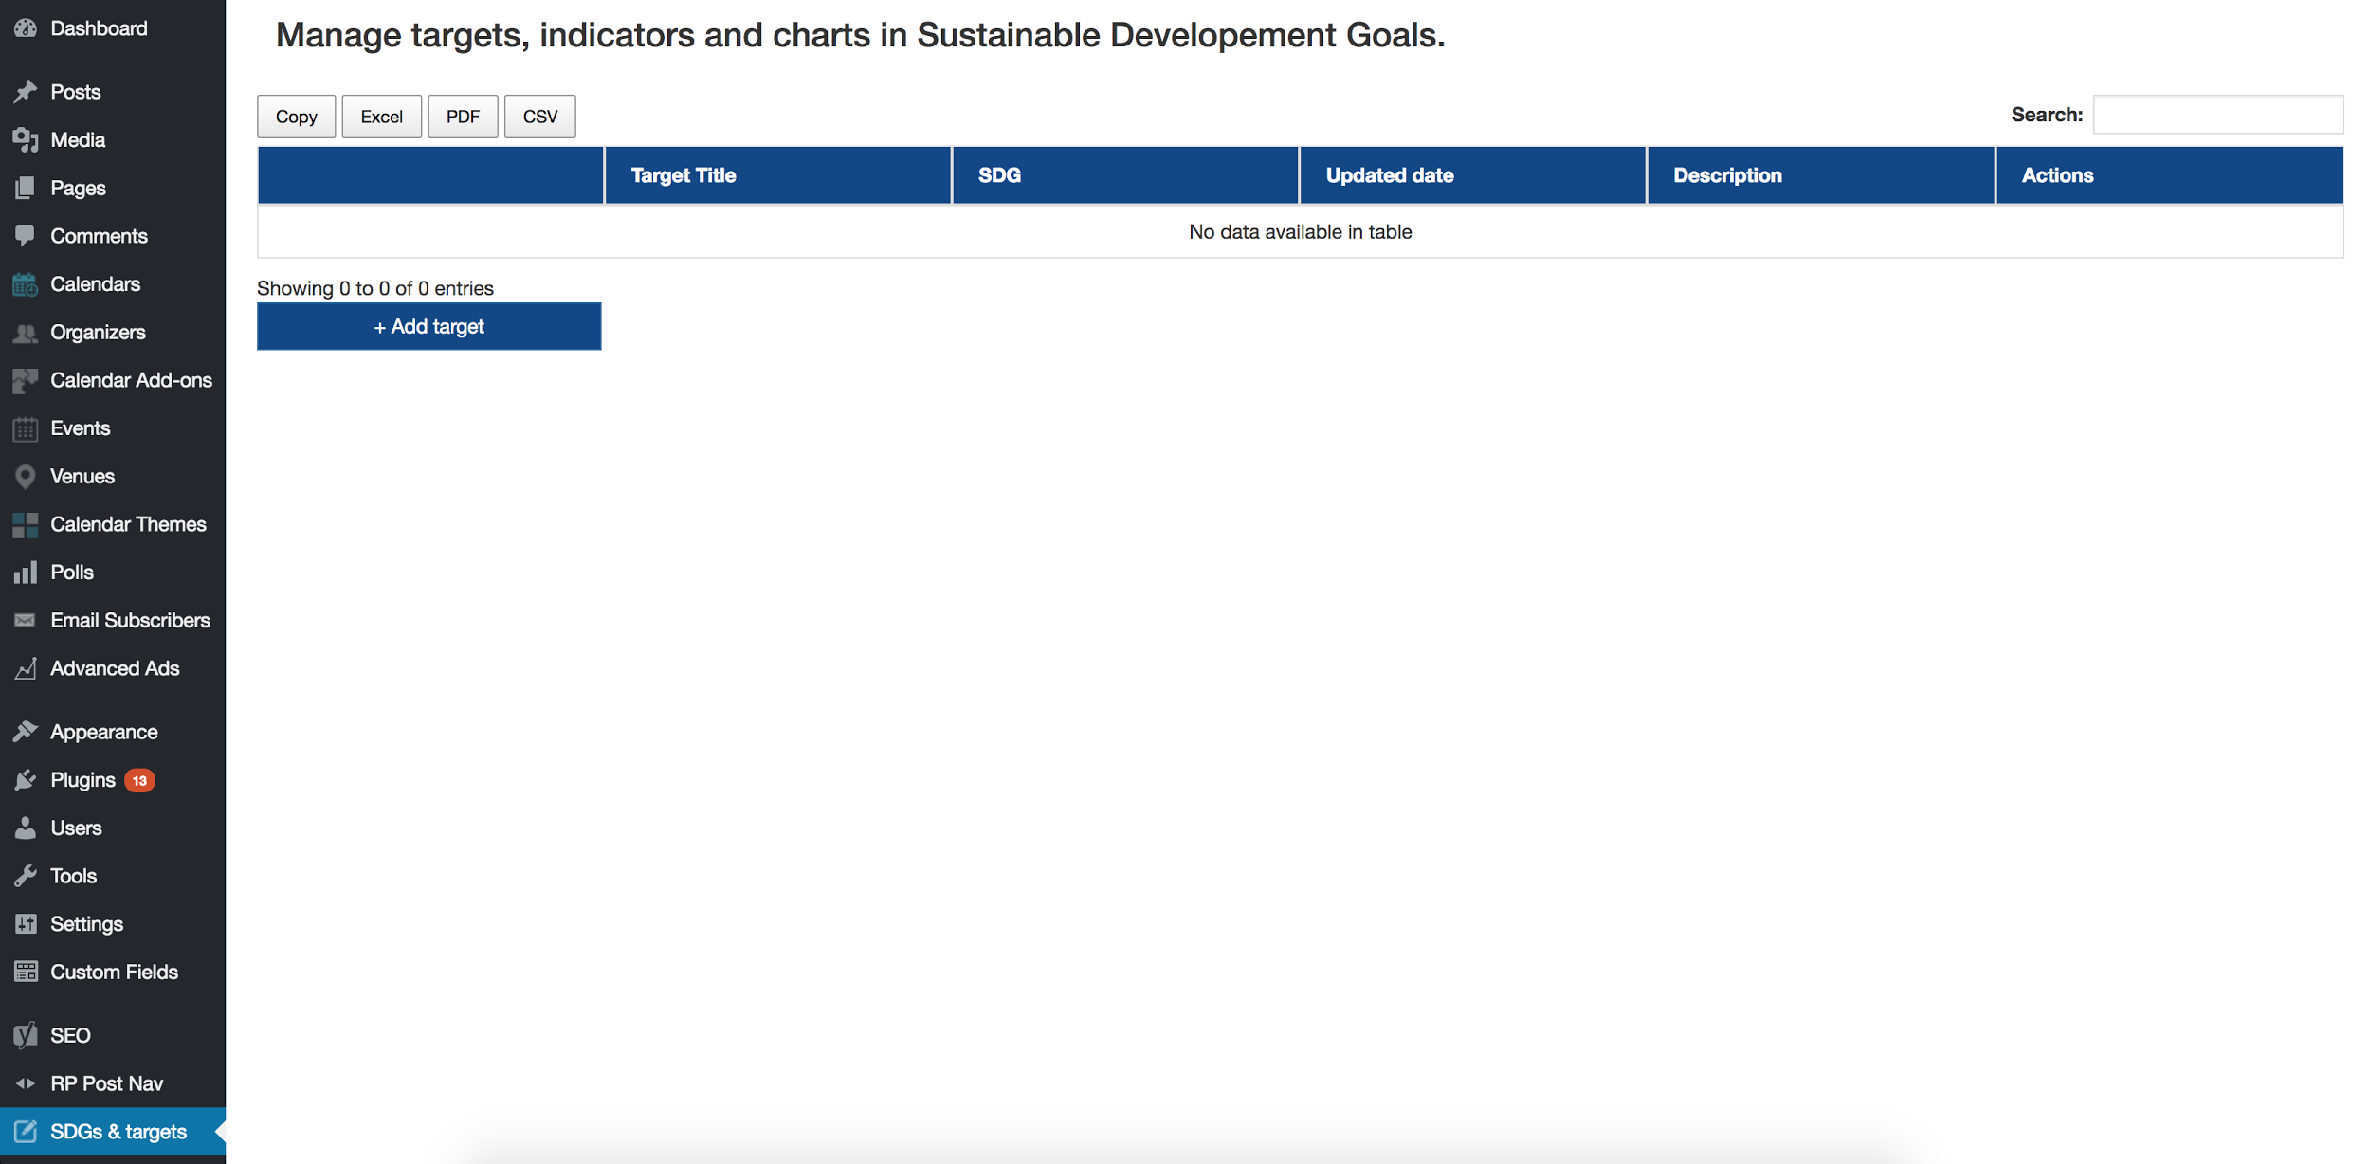

# **Manage Targets**

Find out how to create, edit and delete targets.

## **Creating new target**

1. In the dashboard of “SDGs & Targets” click the button called “+ Add target”.

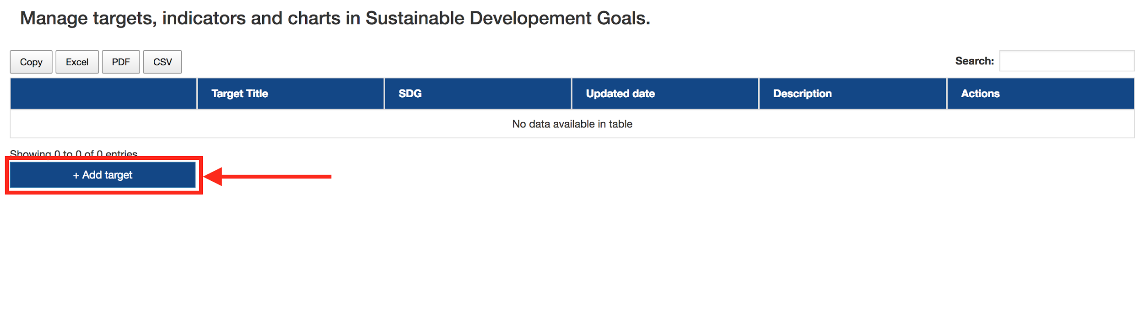

1. Fill out the fields needed in the form for creating a target as below and then click the button “Save Changes” at the bottom of form:

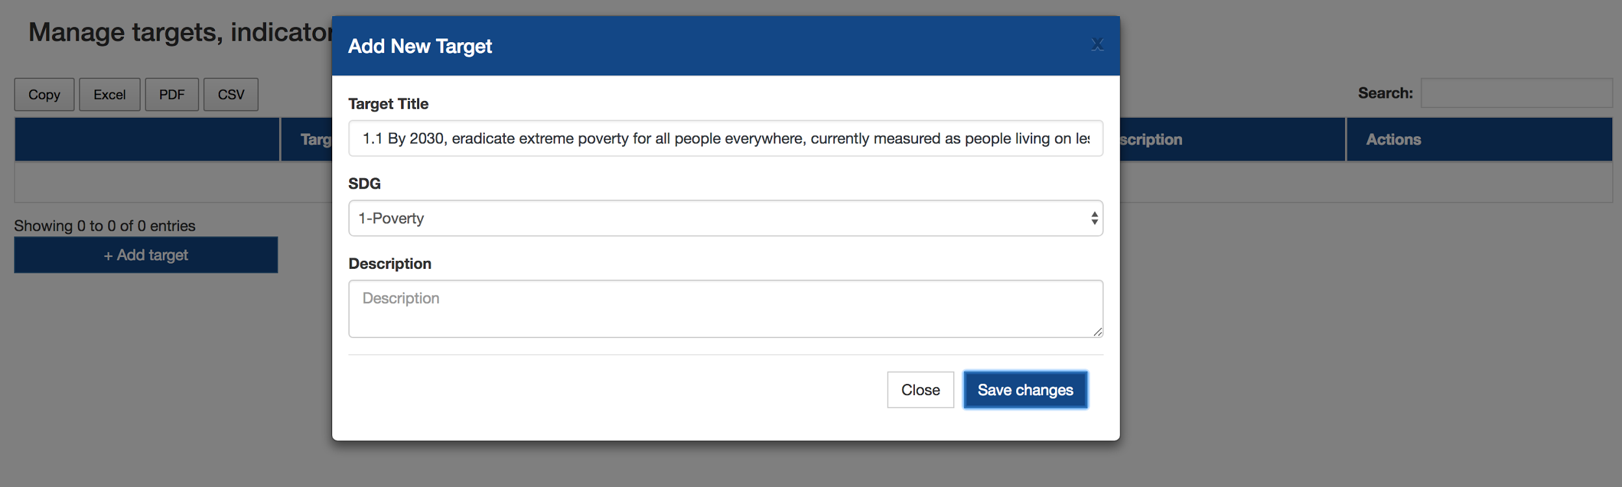

After saving changes for creating new target, you can see that target being listed in the table of targets as seen below:

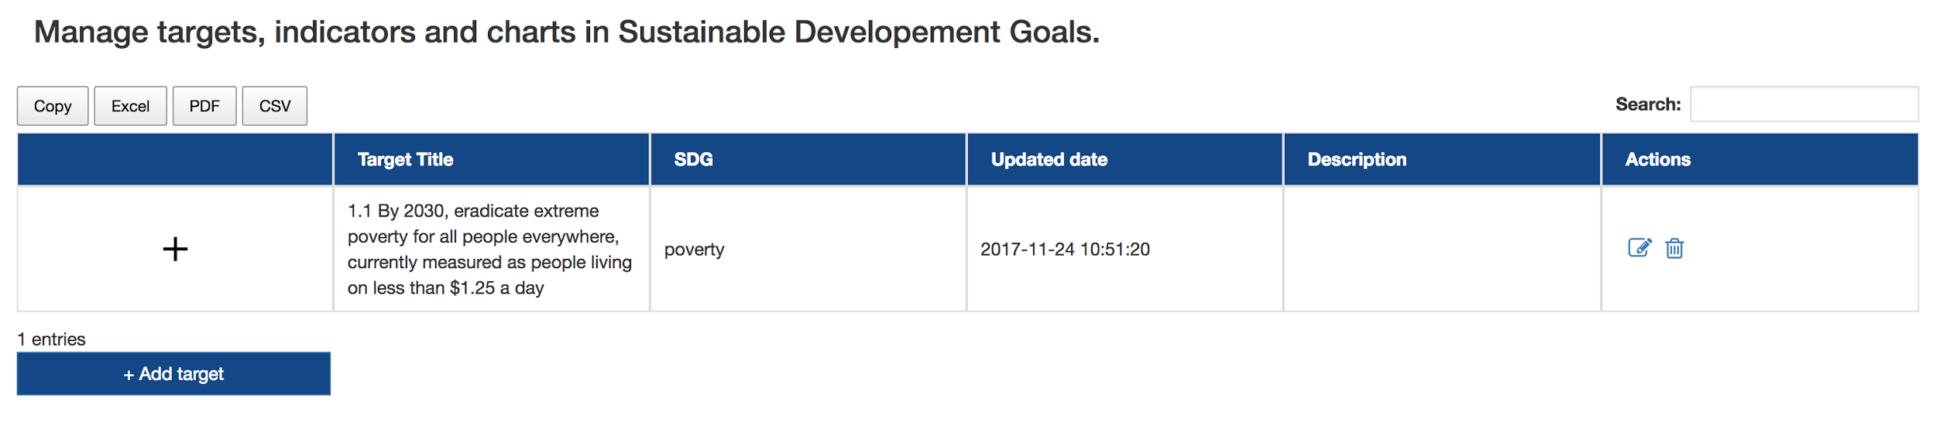

## **Editing targets**

1. Click on the little icon “Edit” in Actions field in target row in table as below:

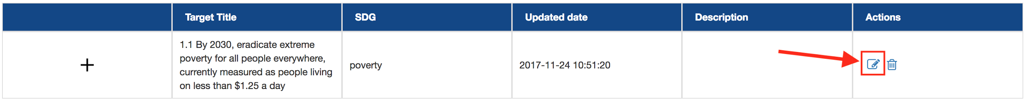

1. Target form will be shown with existing information, feel free to change the data in fields and then click “Save Changes”:

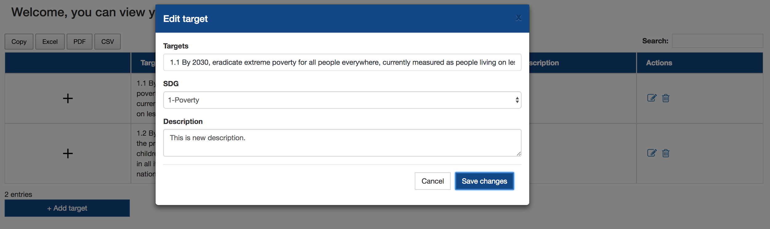

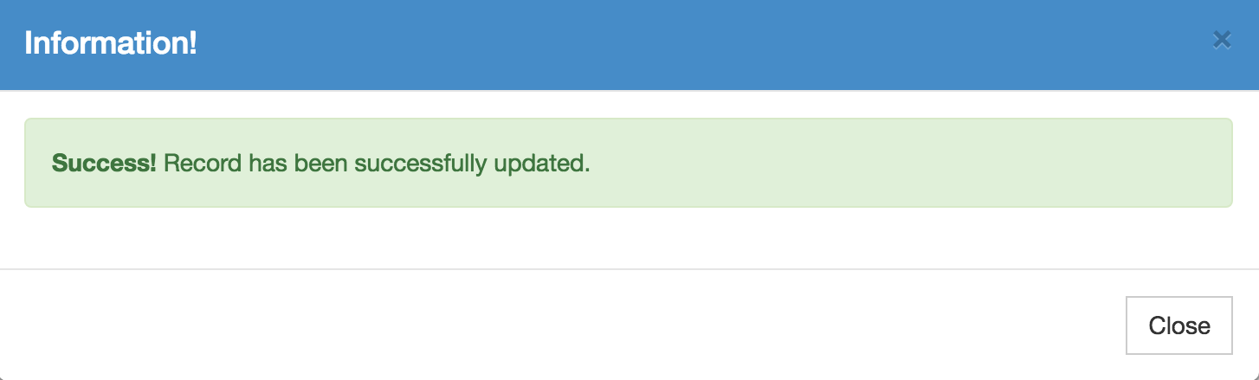After editing and clicking button “Save changes” you will see a message and then updated target will be shown in the target table as seen below:

## 

## **Deleting targets**

1. 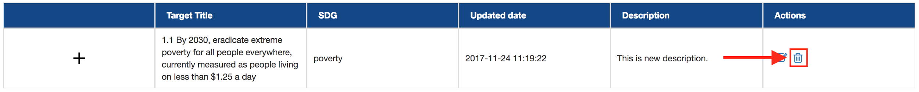Click on the trash icon in Actions fields in specific target row as below:
2. A message will be shown as below:

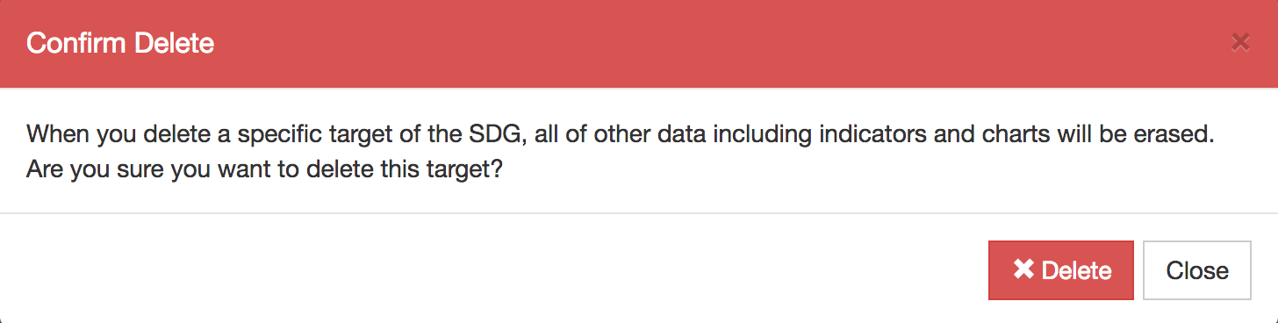

1. If you agree with this warning, click button “Delete” to confirm the deletion.

**Caution: After clicking delete you will not be able to recover that data back.**

# 

# 

# 

# **Manage Indicators**

Find out how to create, edit and delete indicators.

## **Creating new indicator**

1. In order to create indicators, first you have to choose in which target you want to add new indicator then click on the chosen target’s “**Plus sign**” as seen below:

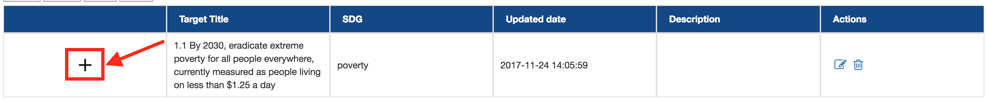

1. Now you can see the table of indicators displayed inside of the target you chose, now you click on the button “**+ Add indicator**” as shown below:

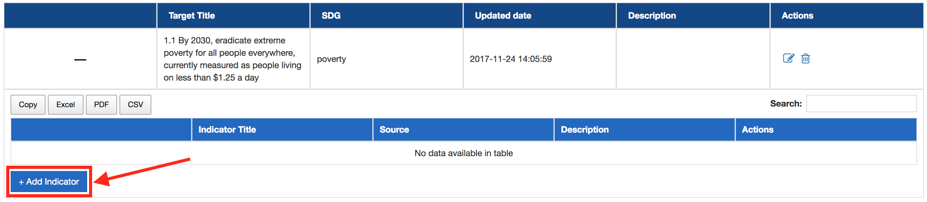

1. 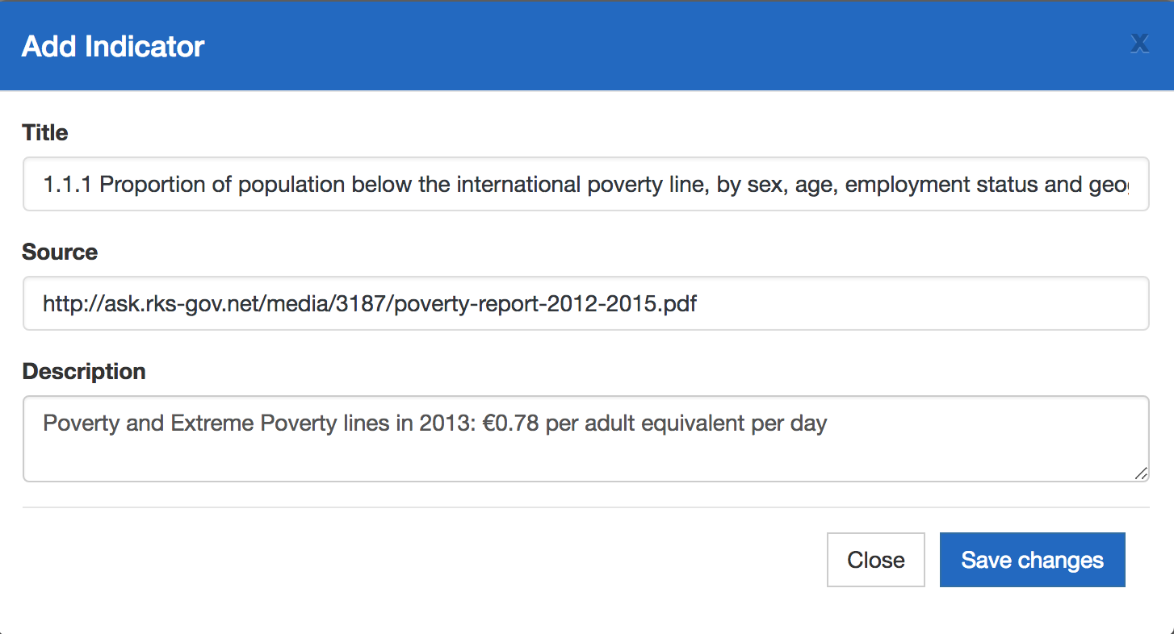The form for creating new indicator is displayed, fill out the fields and click “Save Changes” as seen below:
2. After saving changes, now you can see that indicator in the indicators table inside the chosen target as seen below:

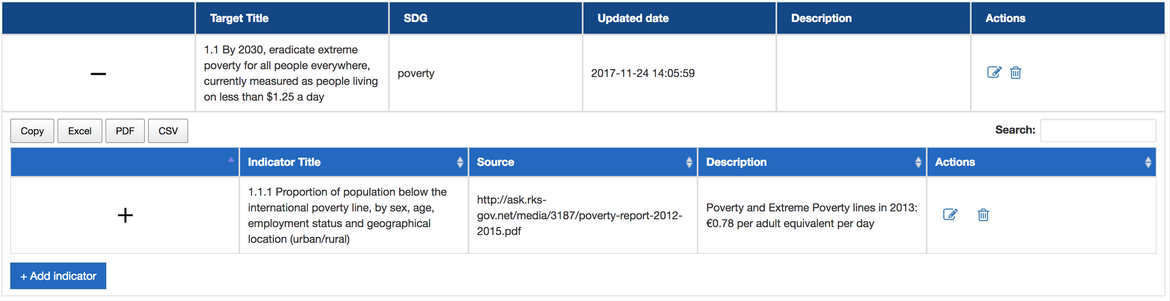

**Note: You can add as many indicators as you want in each target.**

## **Editing indicators**

1. Click on the little icon “Edit” in Actions field in a specific indicator row as below:

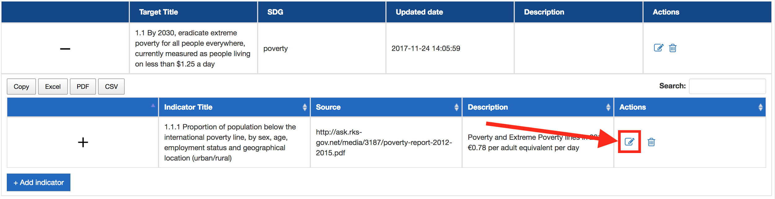

1. Indicator form will be shown with existing information, feel free to change the data in fields and then click “Save Changes”:

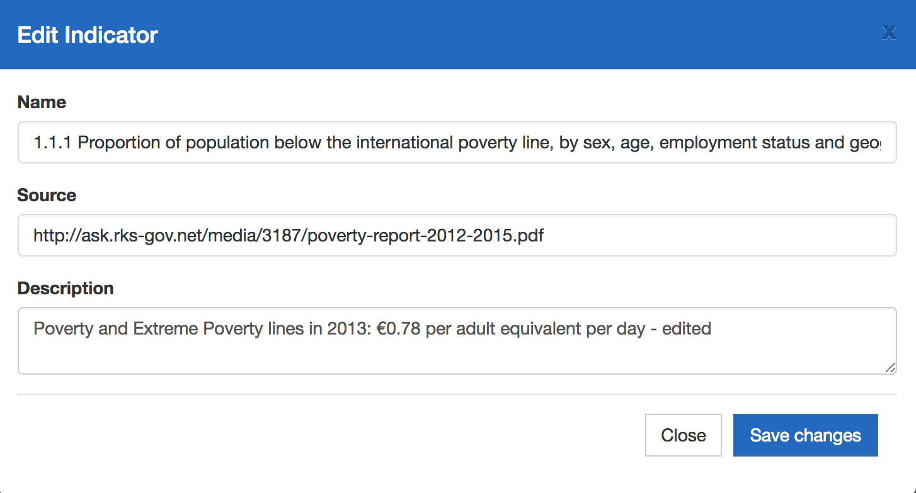

After editing and clicking button “Save changes” you will see a message and then updated indicator will be shown in the indicator table.



## **Deleting indicators**

1. Click on the trash icon in Actions fields in a specific indicator you want to delete as seen below:

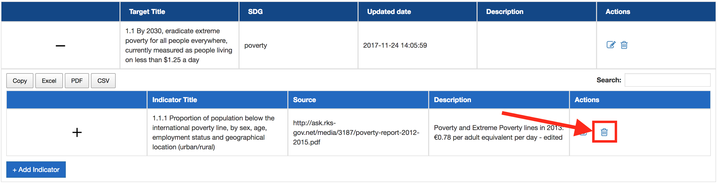

1. A message will be shown as below:

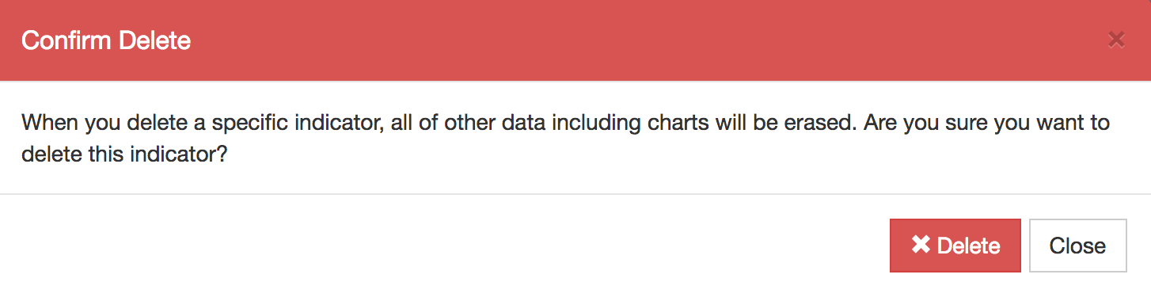

1. If you agree with this warning, click button “Delete” to confirm the deletion.

**Caution: After clicking delete you will not be able to recover that data back.**

# 

# **Manage charts**

Find out how to create different kinds of charts, how to edit and delete charts.

## **Creating new chart**

1. First of all you have to choose in which target’s indicator you want to create new chart. Then you need to click on that indicator’s “**Plus sign**”as seen below:

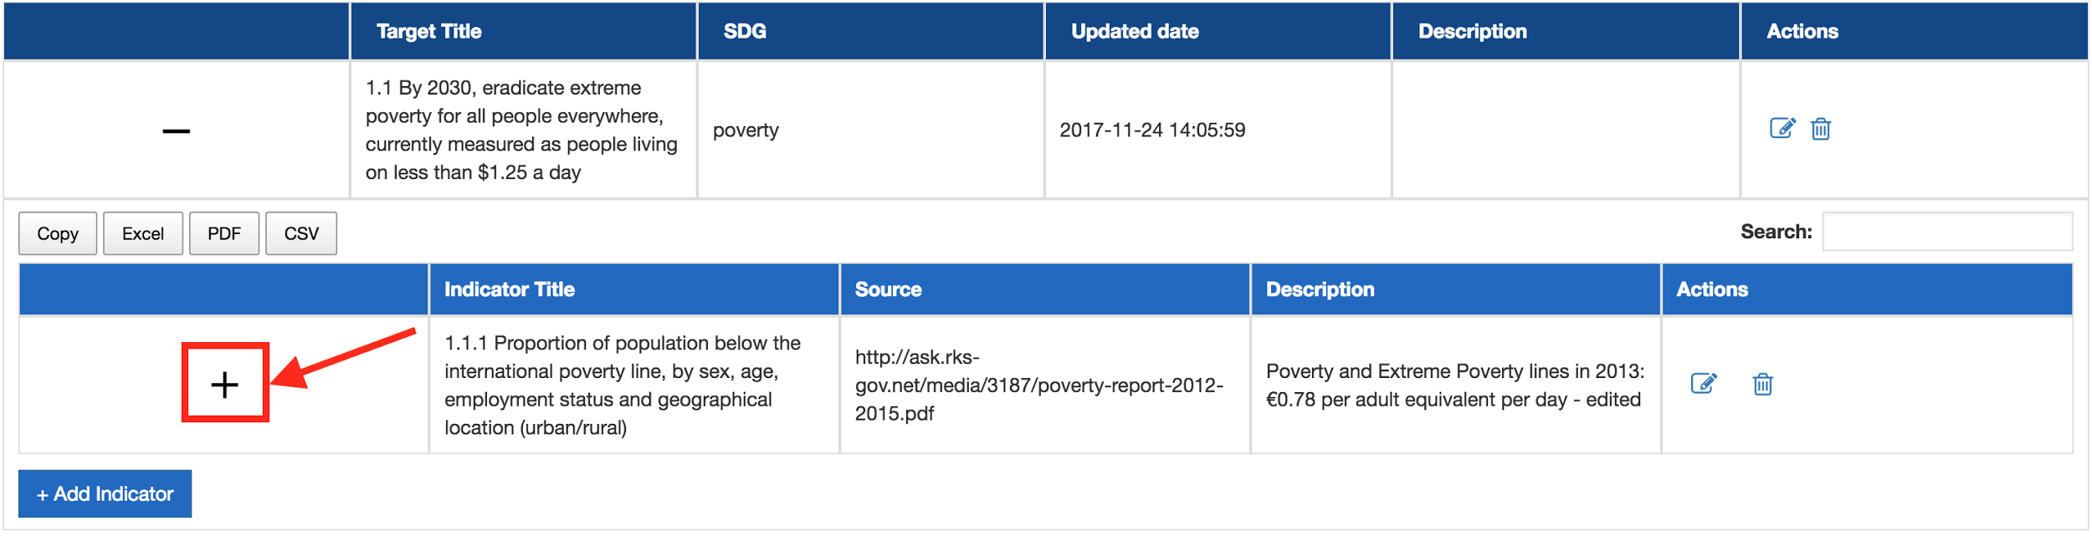

1. Now you can see the chart table displayed inside this indicator, and now click the button “ **+ Add chart**” as shown below:

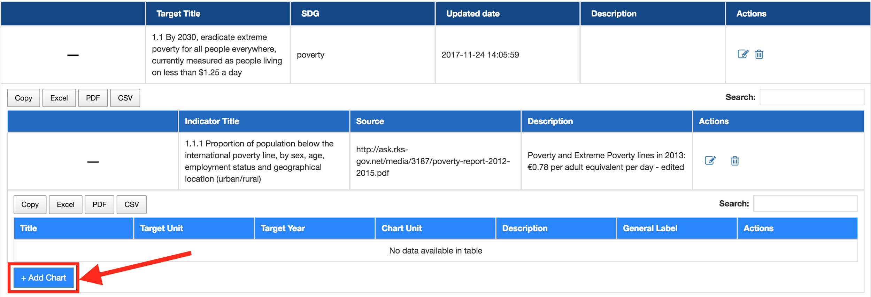

1. 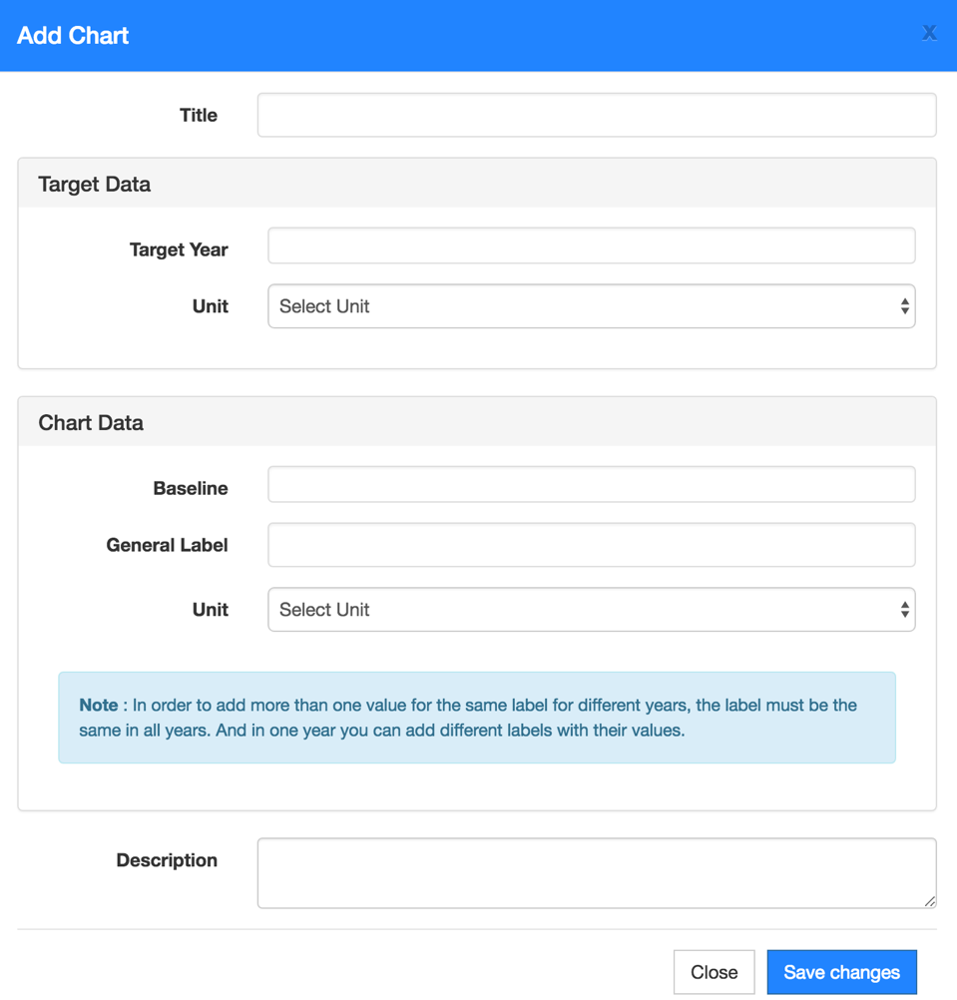The form for creating new charts is displayed as below:

As you can see the form has two main sections “**Target Data**” and “**Chart Data**”.

In the **Target Data** you have to specify the year of target and then choose unit of target value from dropdown as seen below:

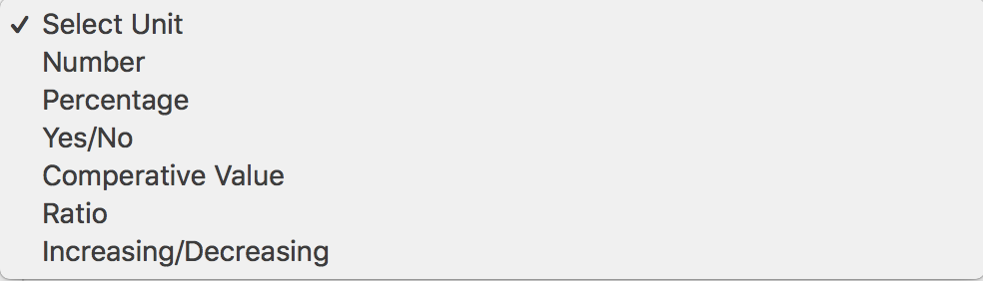

After you choose one of the units from dropdown, you will have to specify the value of target based on chosen unit.

Same thing applies to the **Chart Data** too, first off you have to choose one of the units as seen as below, after you choose the unit you have to set the value based on chosen unit.

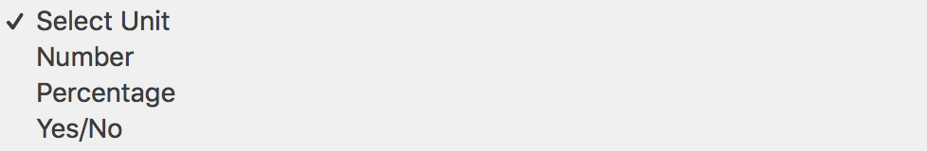

**Note: You can add as many charts as you want in each indicator.**

**Note: In order to add more than one value for the same label for different years, the label must be the same in all years.**

**And in one year you can add different labels with their values.**

## **Chart with unit as Numbers**

Fill out the chart form as seen below in order to create new chart with both target and chart data unit as numbers:

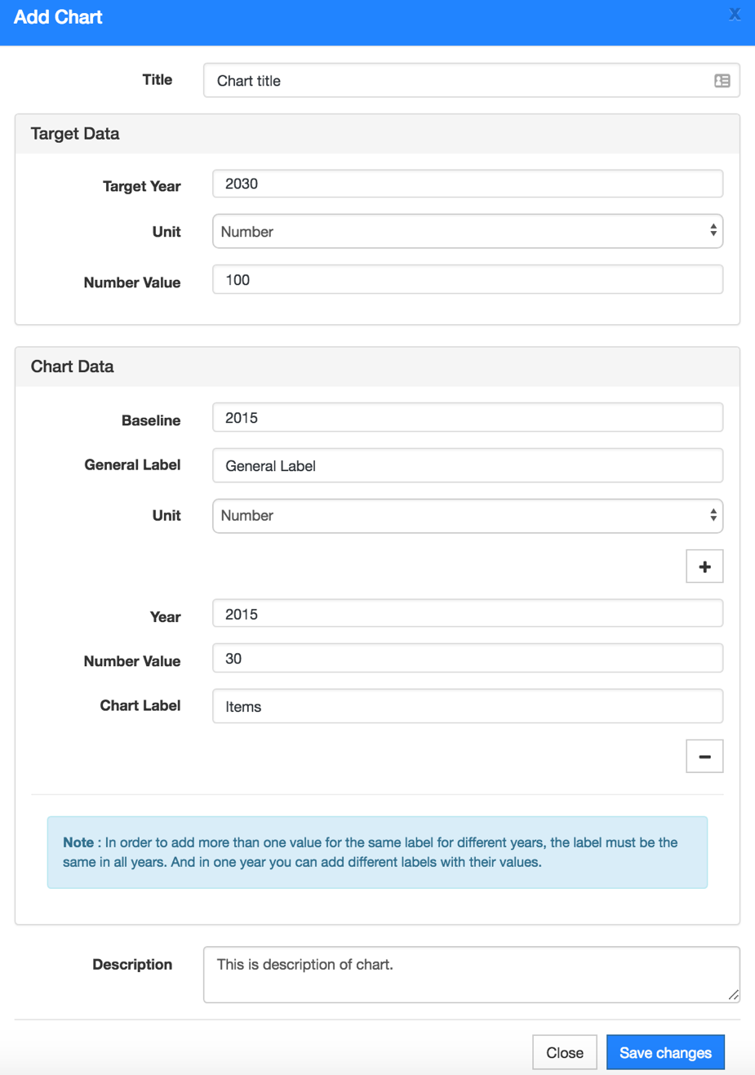

If you want to show another value for that label for another baseline you should click the **Plus** button, and then fill out the same fields.

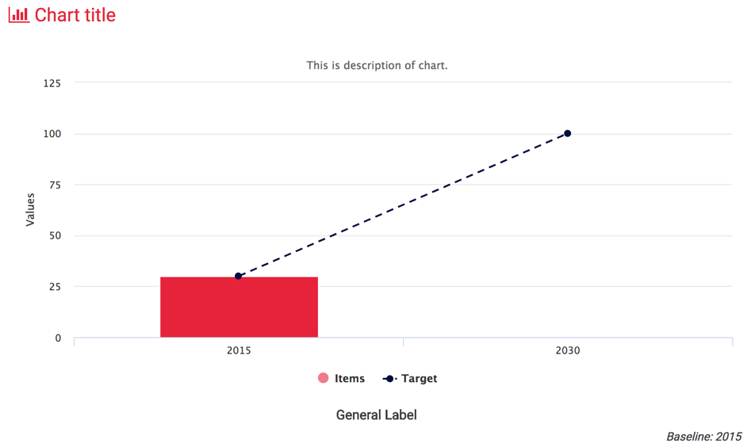

## **Chart with unit as Percentage and Number**

Fill out the form as below in order create a chart with target unit as percentage and chart data unit as number. The number value of chart will be converted based on percentage of target value. If it’s negative percentage value, it will subtract the chart value based on that percentage.

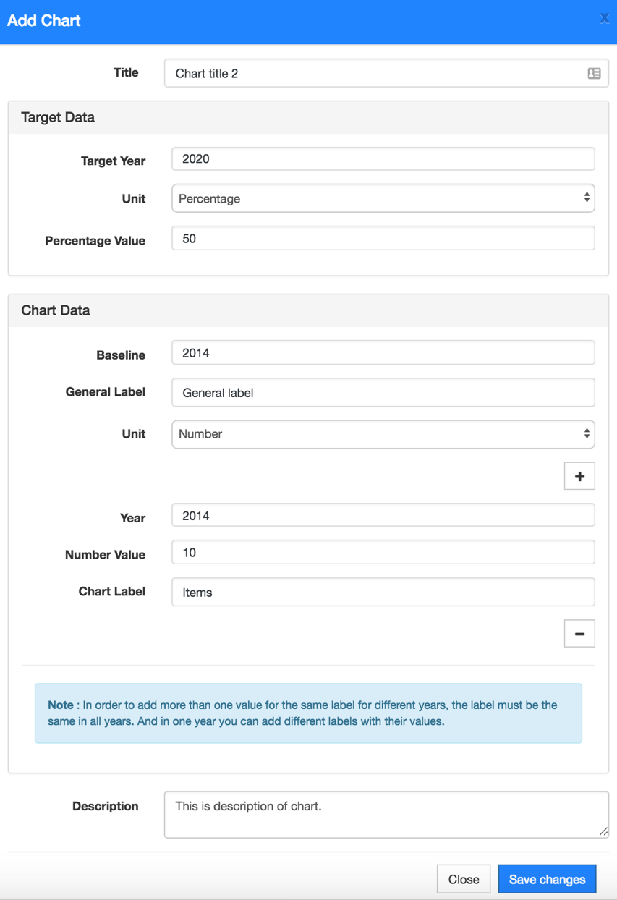

See this chart rendered below:

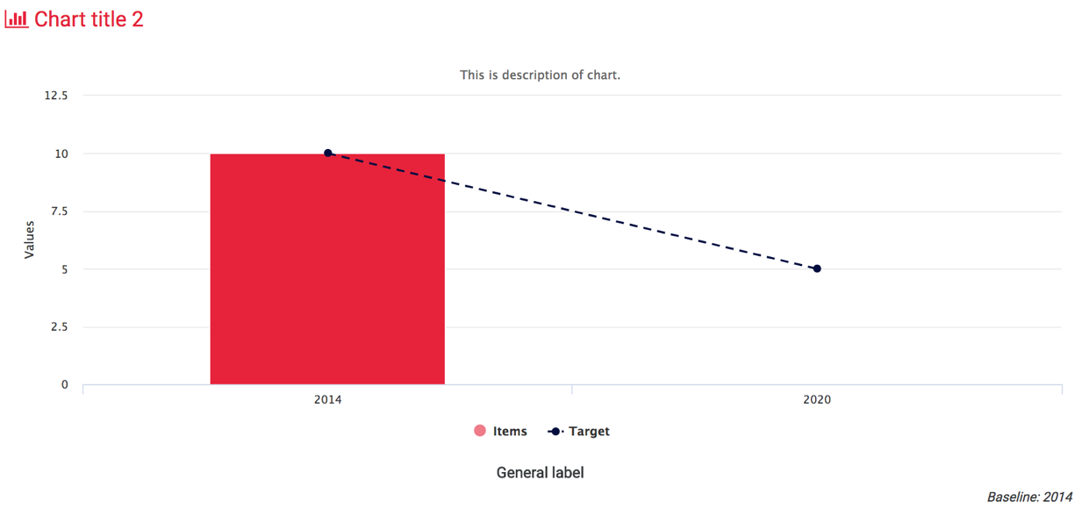

## **Chart with unit as only Percentage**

Fill out the form with information as below in order to render a chart with both target and chart data unit as percentage:

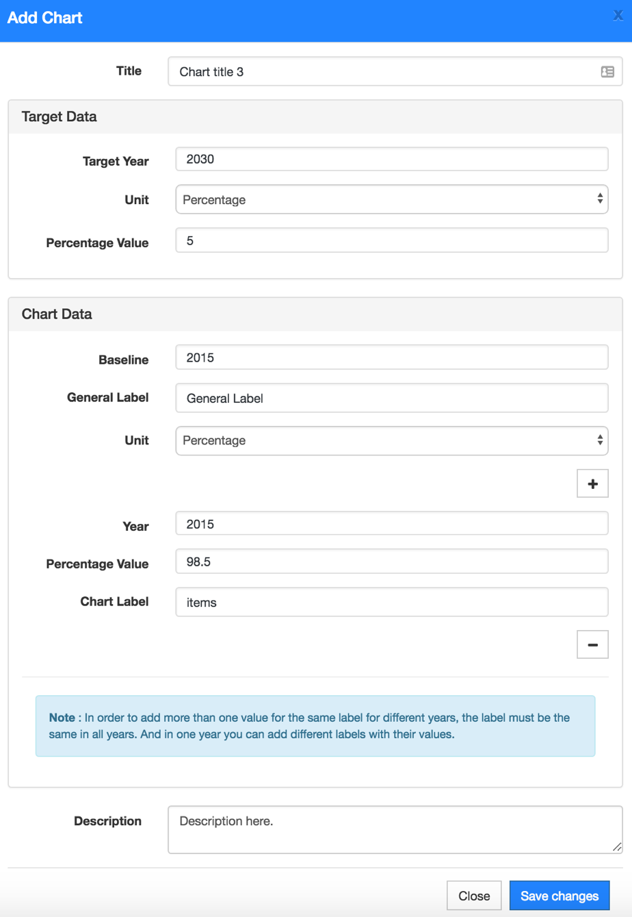

The chart rendered based on data above:

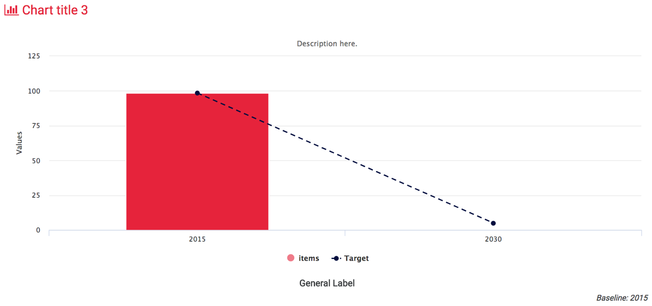

## **Chart with Comparative Value**

Fill out the chart form with data shown as below in order to render a chart with comparative values.

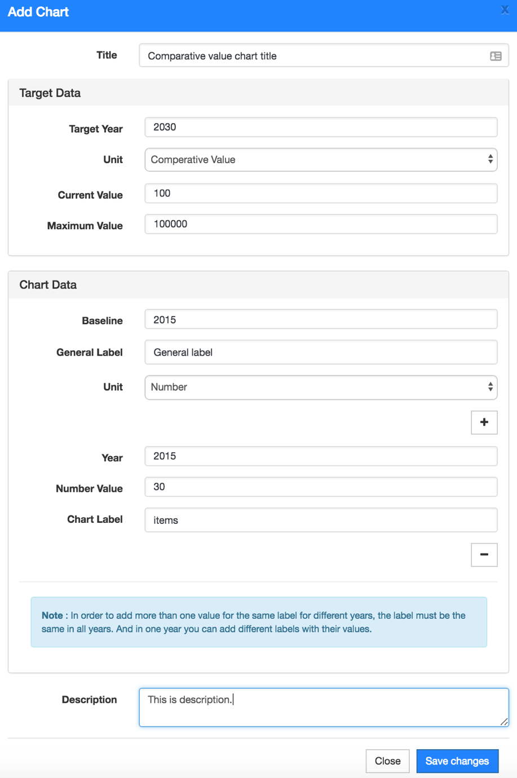

Chart rendered based on data above:

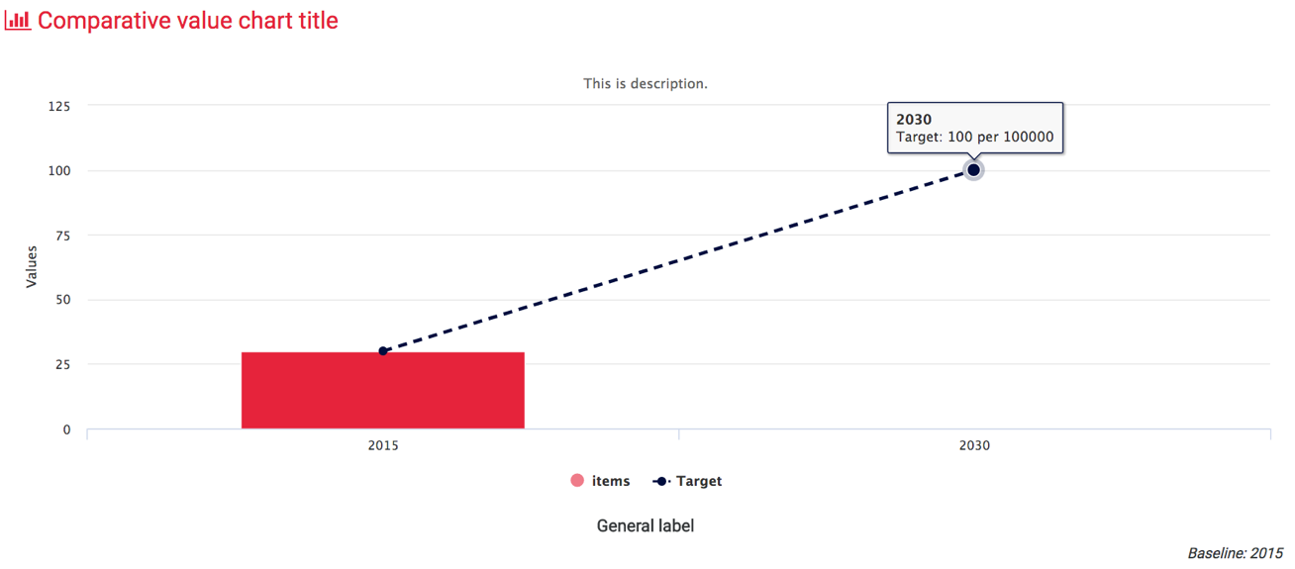

## **Chart with unit as Ratio**

Fill out the chart form with data as below in order to render a chart with target as ratio.

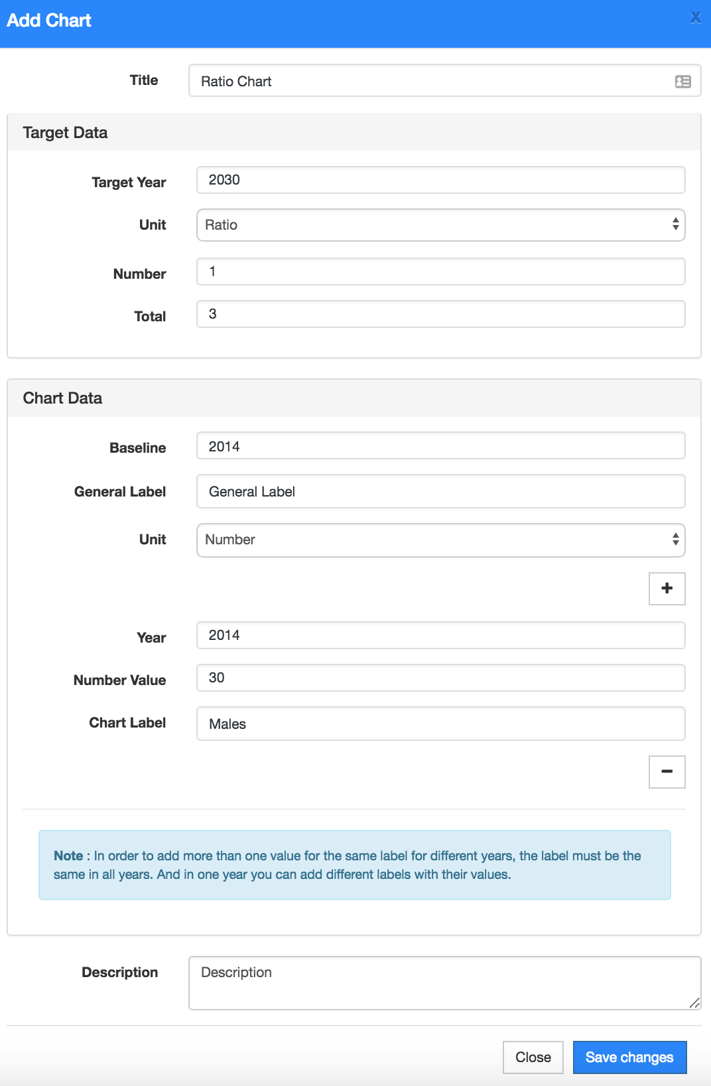

Ratio chart rendered as below:

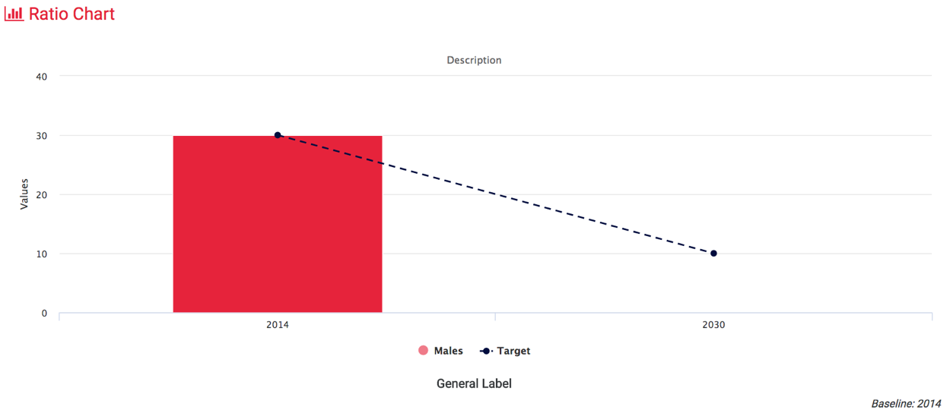

## **Chart with unit as Yes/No**

Fill out the chart form with data similar as below in order to render a chart with Yes/No unit.

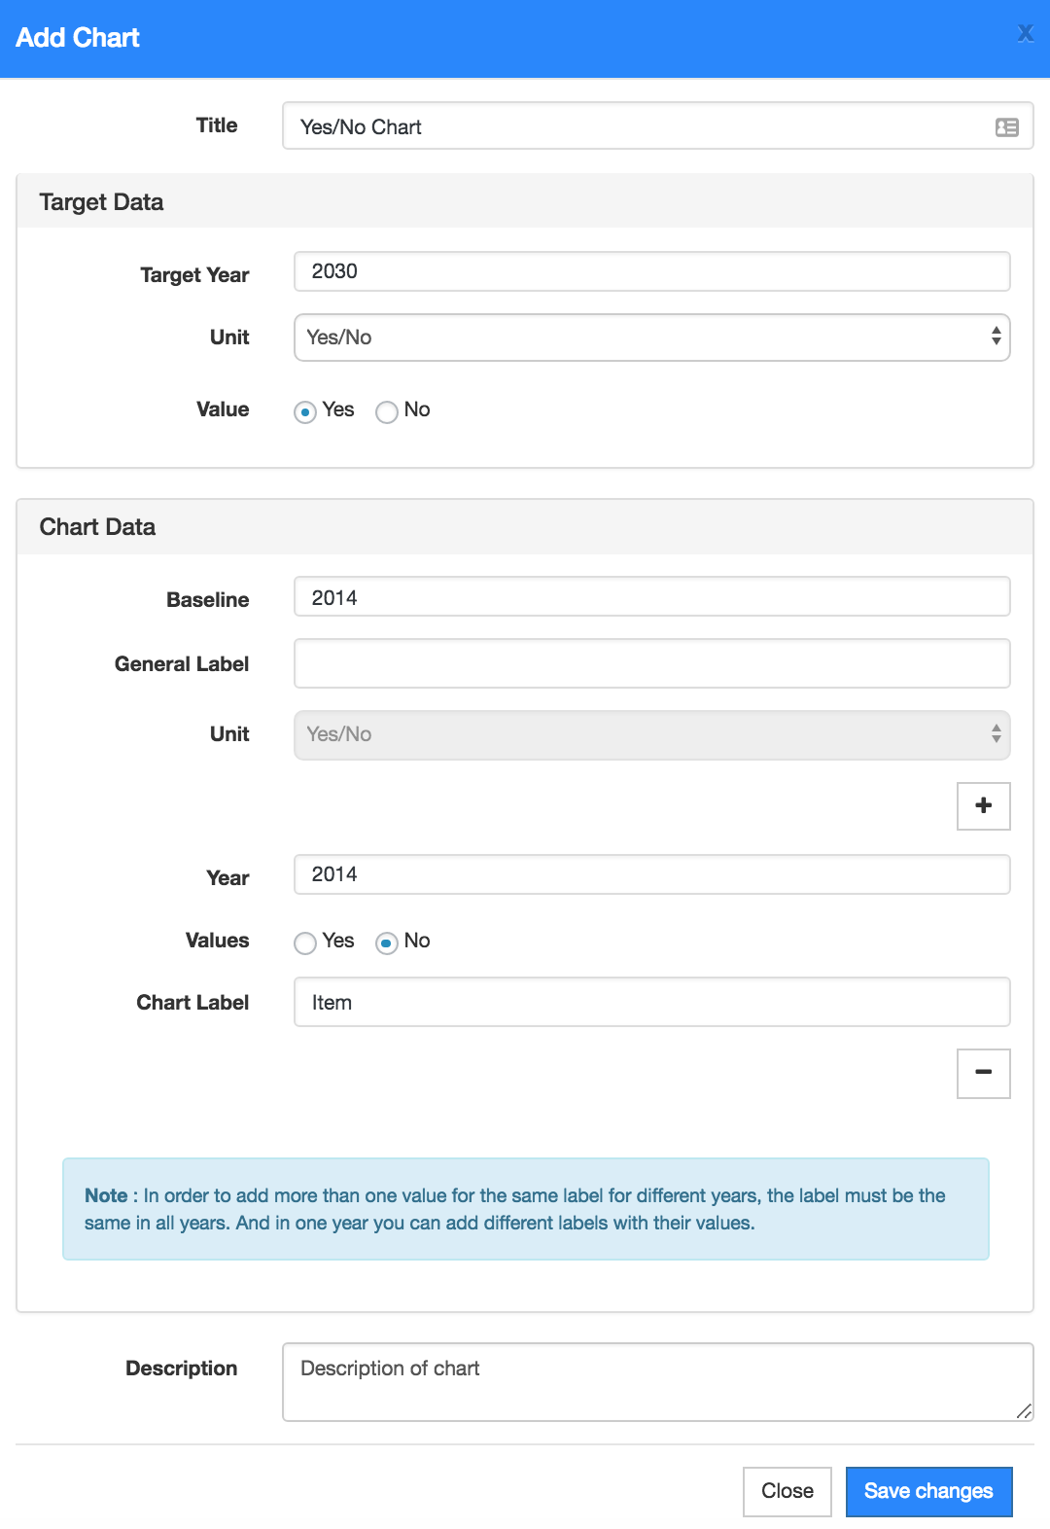

Yes/No chart rendered below based on data above

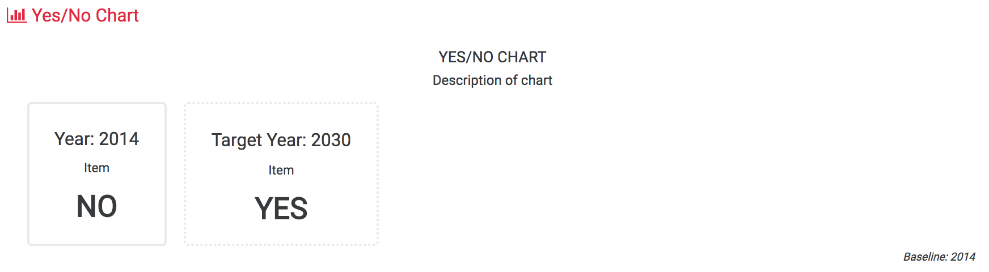

## **Chart with unit as Increasing**

Fill out the chart with data similar as below in order to render a chart with target unit as increasing.

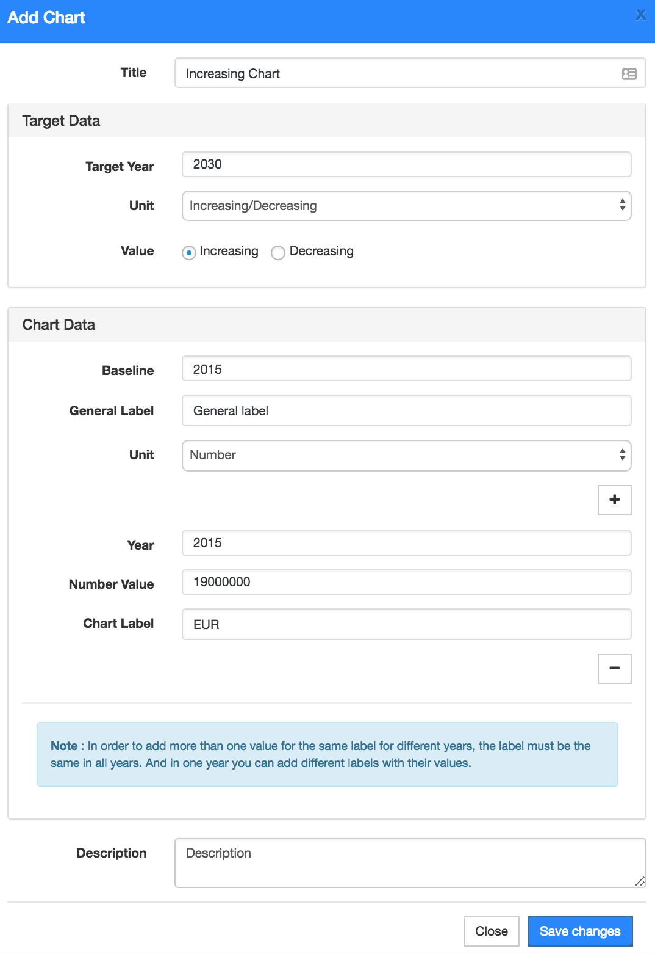

Increasing chart rendered below based on data above.

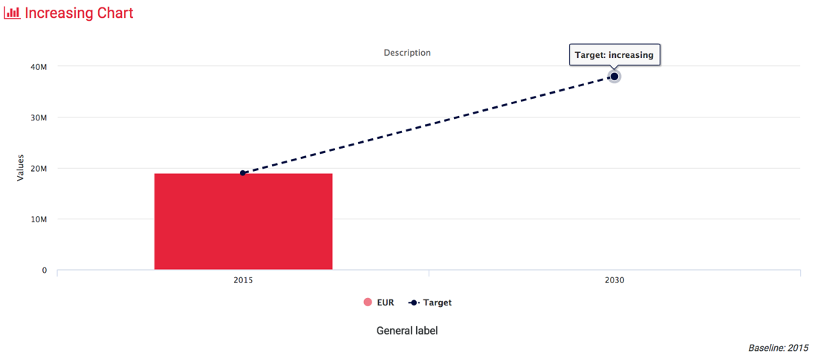

## **Chart with unit as decreasing**

Fill out the chart with data similar as below in order to render a chart with target unit as decreasing.

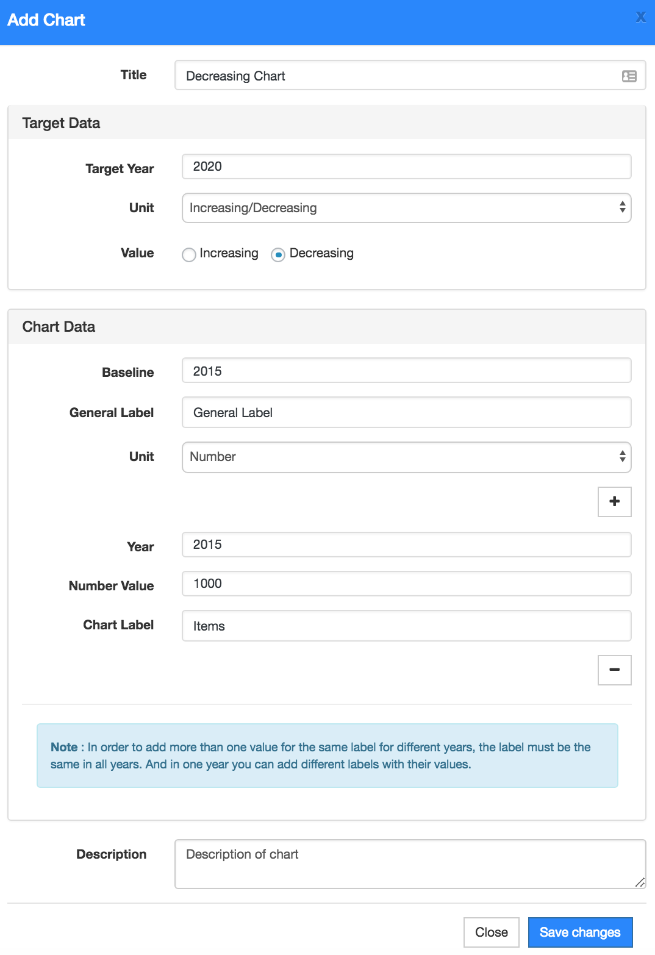

Decreasing chart rendered below based on data above.

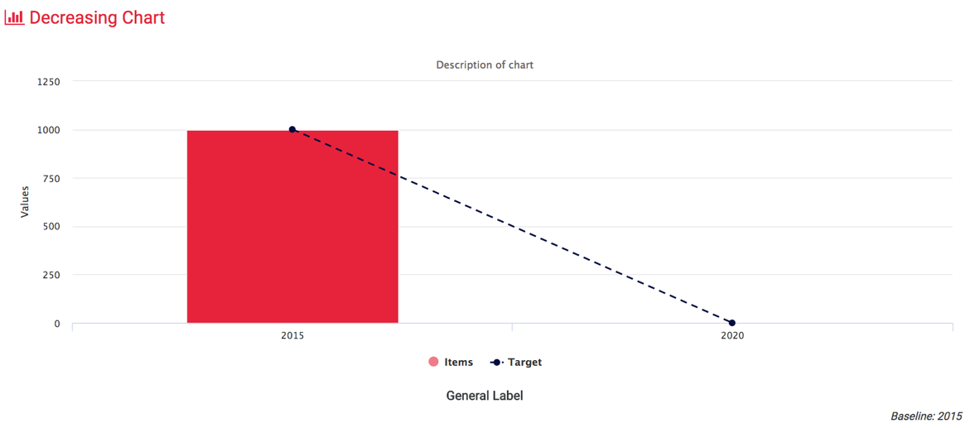

## **Complex chart with more than one data entry**

You can add more than one entry in a chart by clicking **Plus** sign in the **Chart Data**, see the example below:

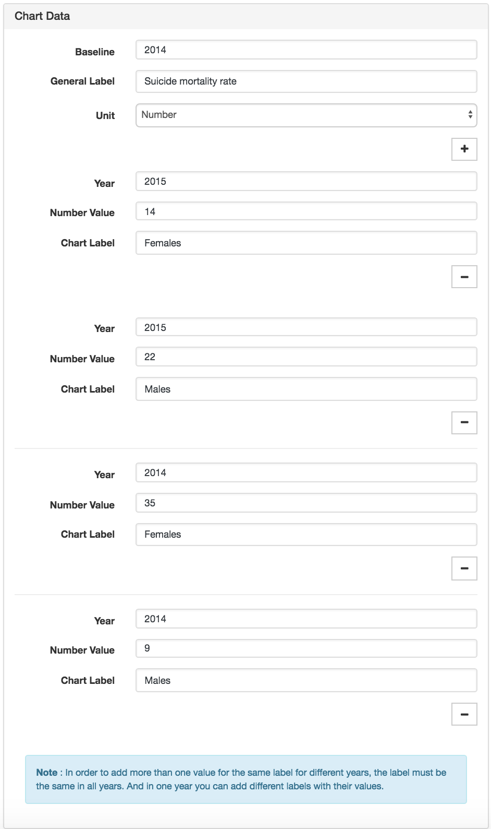

**Note: In order to add more than one value for the same label for different years, the label must be the same in all years.**

**And in one year you can add different labels with their values.**

And target data is:

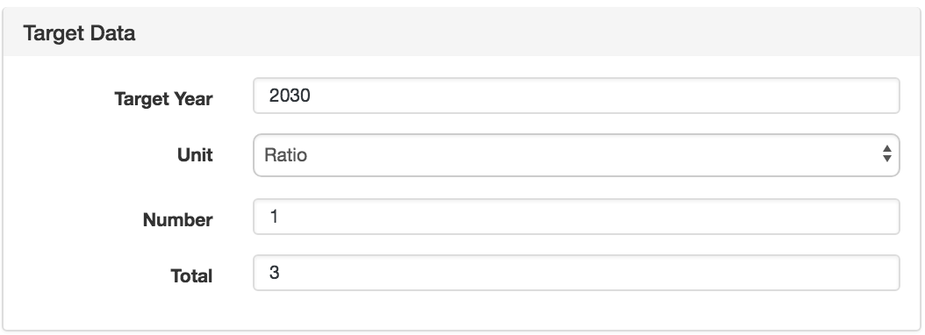

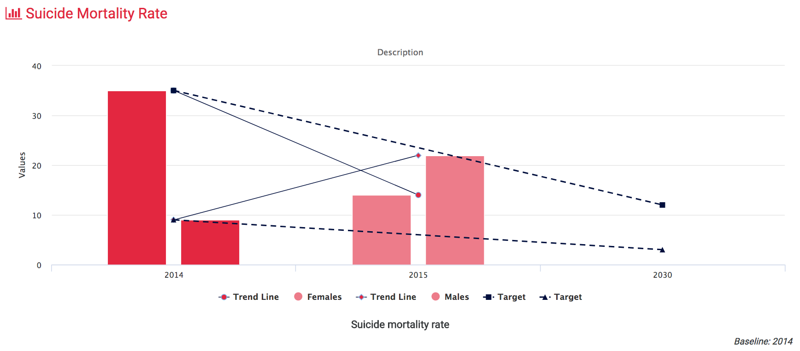The complex chart with data as above is rendered as seen below:

## **Editing charts**

1. Click on the little icon “Edit” in Actions field in a specific chart row as below:
2. Chart form will be shown with existing information, feel free to change the data in all fields and then click “Save Changes”.

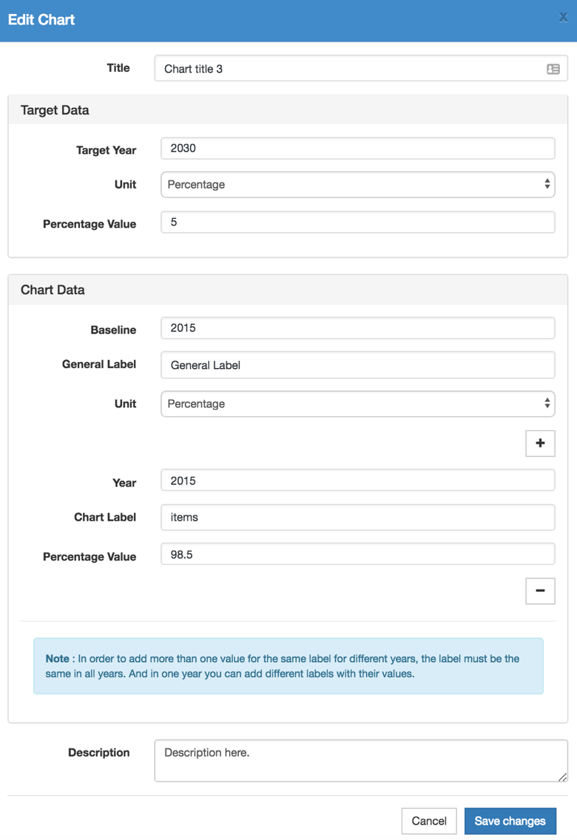

1. After editing and clicking button “Save changes” you will see a message and then updated chart will be shown in the indicator table and re-rendered in show SDG page as well.

## **Deleting charts**

1. Click on the trash icon in Actions fields in a specific chart you want to delete as seen below:
2. A message will be shown as below:

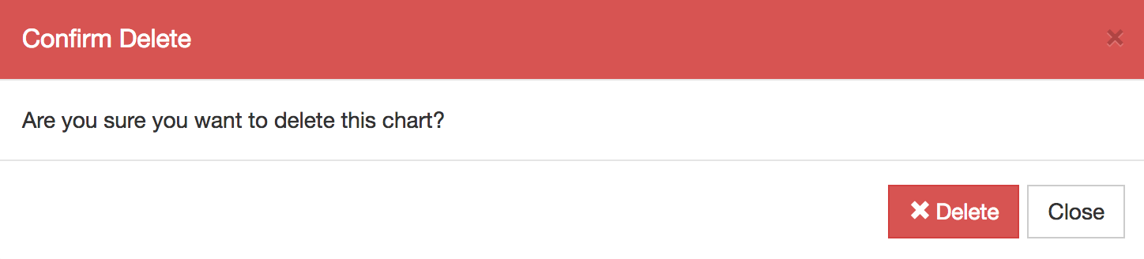

1. If you agree with this warning, click button “Delete” to confirm the deletion of chart.

**Caution: After clicking delete you will not be able to recover that data back.**